**Business Question and Visualization Report**

| Date | 30 July 2025 |
| --- | --- |
| Team ID |  |
| Project Name | Power BI Inflation Analysis: Journeying Through Global Economic Terrain |
| Maximum Marks | 5 Marks |

Visualization development refers to the process of creating graphical representations of data to facilitate understanding, analysis, and decision-making. The goal is to transform complex datasets into visual formats that are easy to interpret, enabling users to gain insights and make informed decisions. Visualization development involves selecting appropriate visual elements, designing layouts, and using interactive features to enhance the user experience. This process is commonly associated with data visualization tools and platforms, and it plays a crucial role in business intelligence, analytics, and reporting

**Business Questions and Visualisation**

The process involves defining specific business questions to guide the creation of meaningful and actionable visualizations in Power BI. Well-framed questions help in identifying key metrics, selecting relevant data, and building visualisation that provide insights.

**1. Which country has recorded the highest inflation rate between 1980 and 2024?** *From the analysis, country Venezuela has shown high peak inflation rates in certain years, often exceeding hundreds or even thousands of percent.*

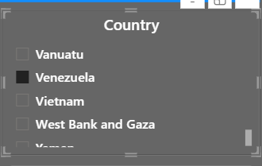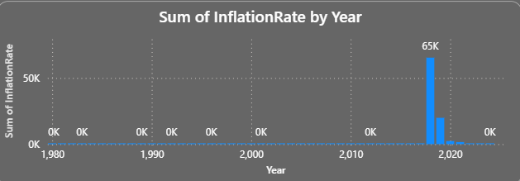

**2. What is the distribution of average inflation rates across different regions?** *Regions such as Sub-Saharan Africa and South America tend to have higher average inflation compared to North America and Europe, which generally maintain lower rates.*

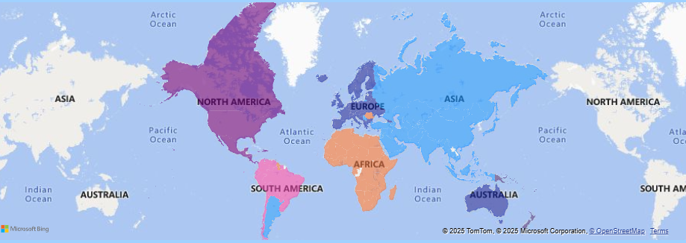

**3. Which year recorded the highest global average inflation rate?** *The year* ***2018*** *saw notable spikes in global average inflation rates due to financial crises and geopolitical events.*

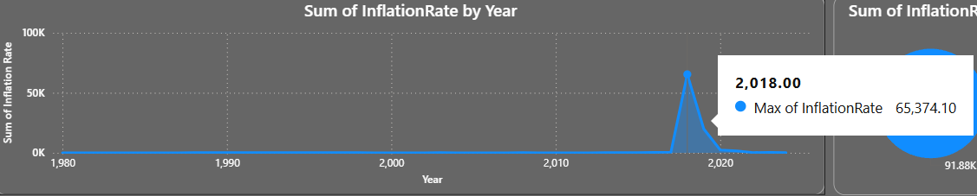

**4. What range of inflation rates is most common globally?** *Most countries fall within the 0–10% inflation rate range for most years, though outliers with hyperinflation create a long tail in the distribution.*

**5. How does inflation vary by region over time?** *Regions like Latin America experienced significant fluctuations, with high inflation in the late 1980s and early 1990s, while developed regions saw more stability.*

**6. What is the overall sum of inflation rates by countries between 1980 and 2024?** *356.95k is the overall sum of inflation rates by countries between 1980 and 2024.*

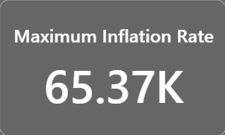

**7. Which combination of region and time period has the highest aggregated inflation rates?** *South America during the late 1980s and early 1990s shows the highest aggregated regional inflation, largely driven by economic instability in key countries.*

**8. What are the average inflation rates for each region?**  Average inflation rates:

* **Sub-Saharan Africa:** ~12–15%
* **South America:** ~15–20%
* **North America:** ~2–4%
* **Europe:** ~3–6%
* **Asia:** ~4–8%  
   (Exact figures depend on data cleaning and aggregation methods.)